Spring bean 初始化

# preInstantiateSingletons

org.springframework.context.support.AbstractApplicationContext

public void preInstantiateSingletons() throws BeansException {  
 if (logger.isTraceEnabled()) {  
 logger.trace("Pre-instantiating singletons in " + this);  
 }  
  
 List<String> beanNames = new ArrayList<>(this.beanDefinitionNames);  
  
 // Trigger initialization of all non-lazy singleton beans...  
 for (String beanName : beanNames) {  
 RootBeanDefinition bd = getMergedLocalBeanDefinition(beanName);

//合并父Bean中的配置，注意 <bean id="" class="" parent="" /> 中的 parent  
 if (!bd.isAbstract() && bd.isSingleton() && !bd.isLazyInit()) { //非抽象、非懒加载的 singletons。如果配置了 'abstract = true'，那是不需要初始化的  
 if (isFactoryBean(beanName)) { // 处理FactoryBean  
 }  
 else {

//非FactoryBean 普通Bean 只要调用 getBean(beanName) 这个方法就可以进行初始化了  
 getBean(beanName);  
 }  
 }

普通bean这里调用getBean

# getBean

@Override  
public Object getBean(String name) throws BeansException {  
 return doGetBean(name, null, null, false);  
}

# doGetBean



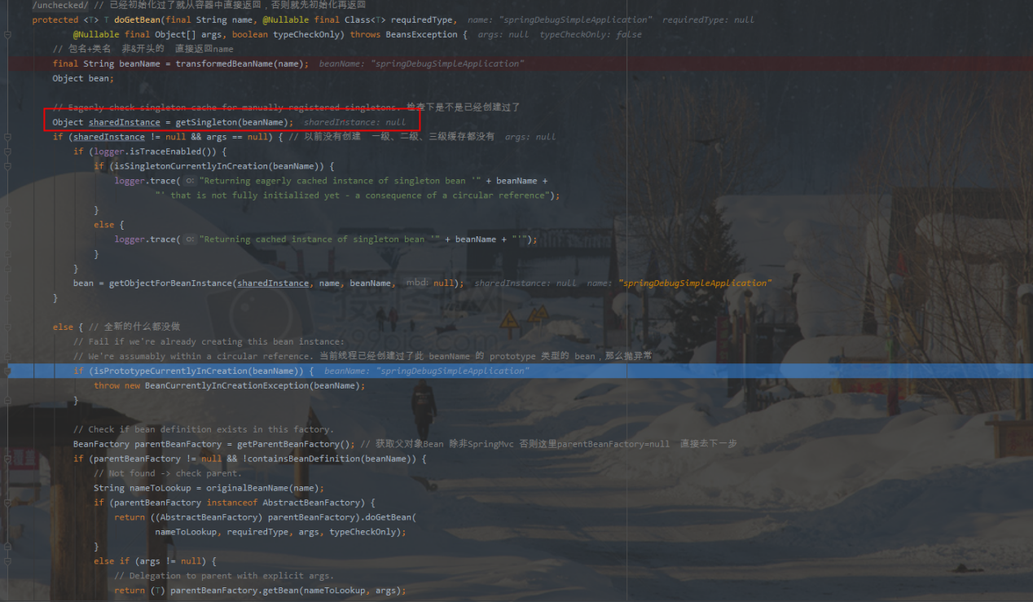

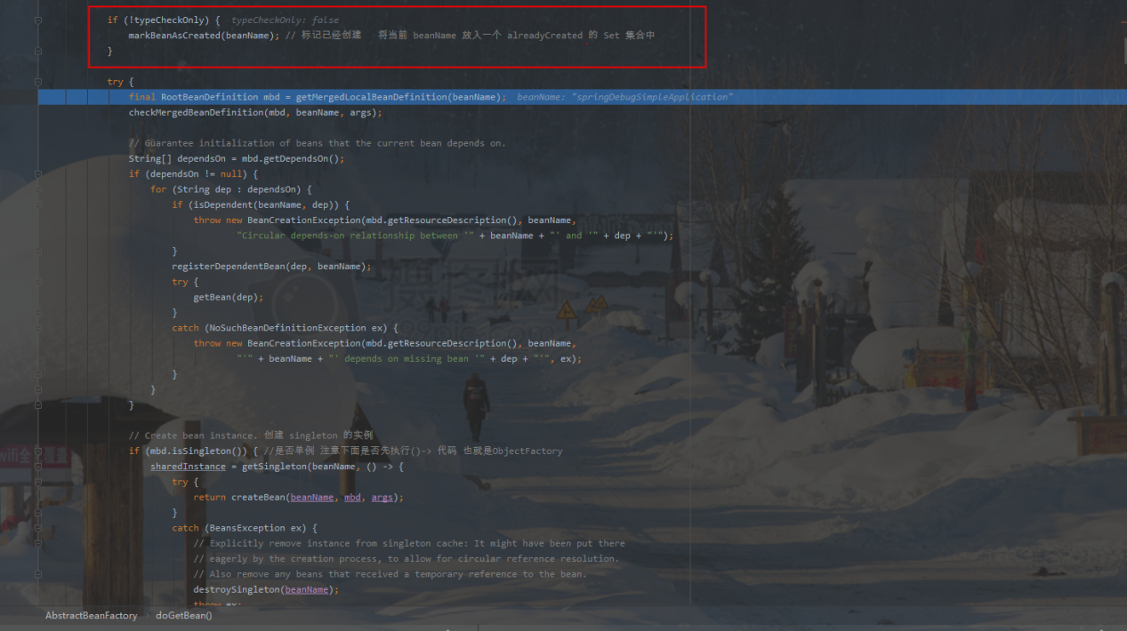

这里把beanName放进创建队列alreadyCreated

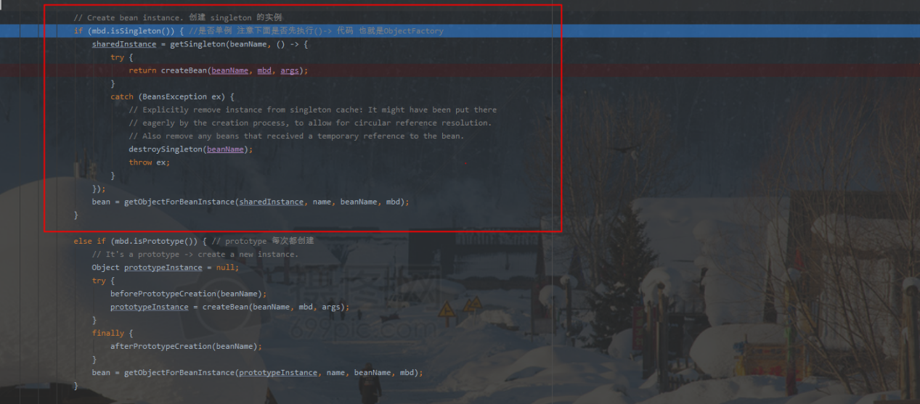

# getSingleton

public Object getSingleton(String beanName) { // 第一次调用这个 allowEarlyReference=true  
 return getSingleton(beanName, true);  
}

# getSingleton(beanName,allowEarlyReference)

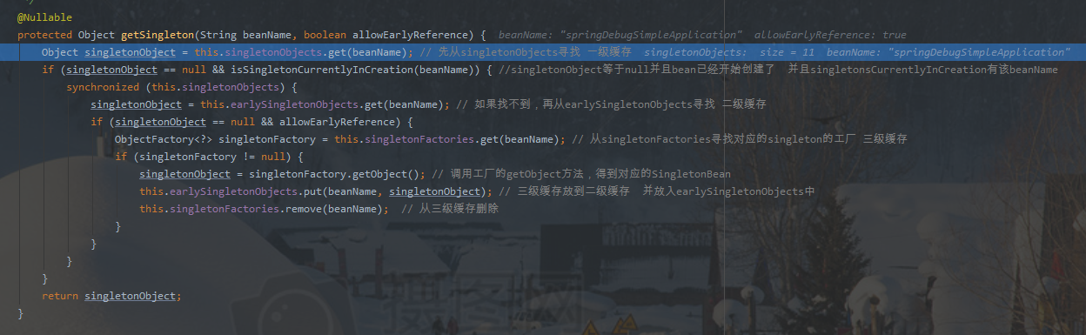

这里时候isSingletonCurrentlyInCreation(beanName)==false

直接return singletonObject 这里是null

# createBean

org.springframework.beans.factory.support.AbstractBeanFactory

protected Object createBean(String beanName, RootBeanDefinition mbd, @Nullable Object[] args)  
 throws BeanCreationException {

try {  
 // Give BeanPostProcessors a chance to return a proxy instead of the target bean instance.  
 Object bean = resolveBeforeInstantiation(beanName, mbdToUse);  
 if (bean != null) {  
 return bean;  
 }  
}  
catch (Throwable ex) {  
 throw new BeanCreationException(mbdToUse.getResourceDescription(), beanName,  
 "BeanPostProcessor before instantiation of bean failed", ex);  
}  
  
try { // ***** 重头戏，创建 bean  
 Object beanInstance = doCreateBean(beanName, mbdToUse, args);  
 if (logger.isTraceEnabled()) {  
 logger.trace("Finished creating instance of bean '" + beanName + "'");  
 }  
 return beanInstance;  
}

}

# doCreateBean

protected Object doCreateBean(final String beanName, final RootBeanDefinition mbd, final @Nullable Object[] args)  
 throws BeanCreationException {  
  
 // Instantiate the bean.  
 BeanWrapper instanceWrapper = null;  
 if (mbd.isSingleton()) {  
 instanceWrapper = this.factoryBeanInstanceCache.remove(beanName);  
 }  
 if (instanceWrapper == null) {  
 instanceWrapper = createBeanInstance(beanName, mbd, args); // 说明不是 FactoryBean，这里实例化 Bean，这里非常关键  
 }  
 final Object bean = instanceWrapper.getWrappedInstance();  
 Class<?> beanType = instanceWrapper.getWrappedClass();  
 if (beanType != NullBean.class) {  
 mbd.resolvedTargetType = beanType;  
 }  
  
 // Allow post-processors to modify the merged bean definition.  
 synchronized (mbd.postProcessingLock) {  
 if (!mbd.postProcessed) {  
 try {  
 applyMergedBeanDefinitionPostProcessors(mbd, beanType, beanName);  
 }  
 catch (Throwable ex) {  
 throw new BeanCreationException(mbd.getResourceDescription(), beanName,  
 "Post-processing of merged bean definition failed", ex);  
 }  
 mbd.postProcessed = true;  
 }  
 }  
  
 // Eagerly cache singletons to be able to resolve circular references  
 // even when triggered by lifecycle interfaces like BeanFactoryAware.  
 boolean earlySingletonExposure = (mbd.isSingleton() && this.allowCircularReferences &&  
 isSingletonCurrentlyInCreation(beanName)); // 是否在singletonsCurrentlyInCreation创建队列里  
 if (earlySingletonExposure) {  
 if (logger.isTraceEnabled()) {  
 logger.trace("Eagerly caching bean '" + beanName +  
 "' to allow for resolving potential circular references");  
 }  
 addSingletonFactory(beanName, () -> getEarlyBeanReference(beanName, mbd, bean)); //放入三级缓存 singletonFactories 非单例的，就不会预加载  
 }  
  
 // Initialize the bean instance.  
 Object exposedObject = bean;  
 try { //对bean进行填充，将各个属性值注入，其中，可能存在依赖于其他bean的属性，则会递归初始依赖bean  
 populateBean(beanName, mbd, instanceWrapper);  
 exposedObject = initializeBean(beanName, exposedObject, mbd); // 调用init 方法  
 }  
 catch (Throwable ex) {  
 if (ex instanceof BeanCreationException && beanName.equals(((BeanCreationException) ex).getBeanName())) {  
 throw (BeanCreationException) ex;  
 }  
 else {  
 throw new BeanCreationException(  
 mbd.getResourceDescription(), beanName, "Initialization of bean failed", ex);  
 }  
 }  
  
 if (earlySingletonExposure) { //(mbd.isSingleton() && this.allowCircularReferences && isSingletonCurrentlyInCreation(beanName))  
 Object earlySingletonReference = getSingleton(beanName, false);  
 if (earlySingletonReference != null) {  
 if (exposedObject == bean) {  
 exposedObject = earlySingletonReference;  
 }  
 else if (!this.allowRawInjectionDespiteWrapping && hasDependentBean(beanName)) {  
 String[] dependentBeans = getDependentBeans(beanName);  
 Set<String> actualDependentBeans = new LinkedHashSet<>(dependentBeans.length);  
 for (String dependentBean : dependentBeans) {  
 if (!removeSingletonIfCreatedForTypeCheckOnly(dependentBean)) {  
 actualDependentBeans.add(dependentBean);  
 }  
 }  
 if (!actualDependentBeans.isEmpty()) {  
 throw new BeanCurrentlyInCreationException(beanName,  
 "Bean with name '" + beanName + "' has been injected into other beans [" +  
 StringUtils.*collectionToCommaDelimitedString*(actualDependentBeans) +  
 "] in its raw version as part of a circular reference, but has eventually been " +  
 "wrapped. This means that said other beans do not use the final version of the " +  
 "bean. This is often the result of over-eager type matching - consider using " +  
 "'getBeanNamesOfType' with the 'allowEagerInit' flag turned off, for example.");  
 }  
 }  
 }  
 }  
  
 // Register bean as disposable.  
 try {  
 registerDisposableBeanIfNecessary(beanName, bean, mbd);  
 }  
 catch (BeanDefinitionValidationException ex) {  
 throw new BeanCreationException(  
 mbd.getResourceDescription(), beanName, "Invalid destruction signature", ex);  
 }  
  
 return exposedObject;  
}

# addSingletonFactory

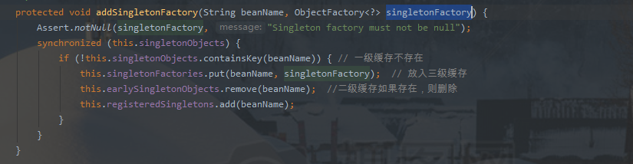

# getEarlyBeanReference

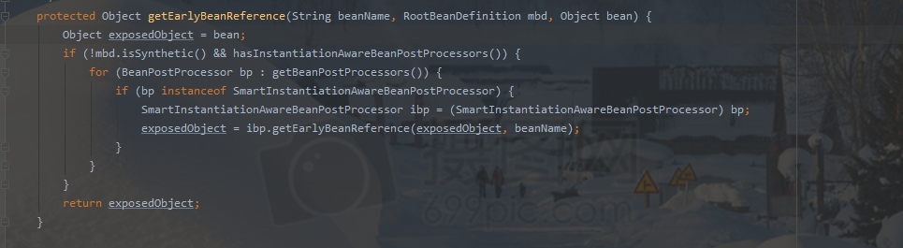

一开始还没调用

# 第二次调用getSingleton(beanName, false);

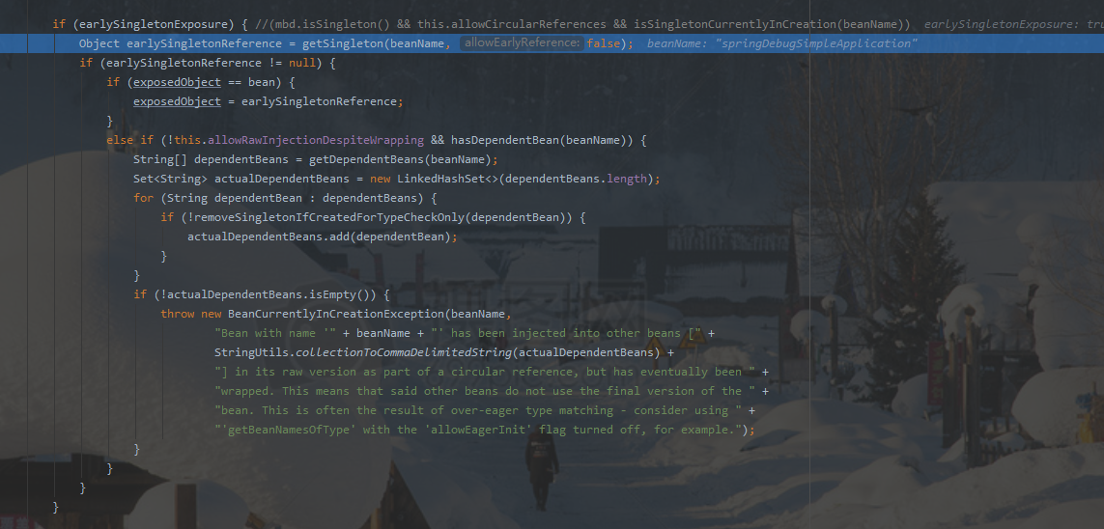

allowEarlyReference=false isSingletonCurrentlyInCreation(beanName)=true

if (singletonObject == null && allowEarlyReference) {} //allowEarlyReference=false

这里也是返回null

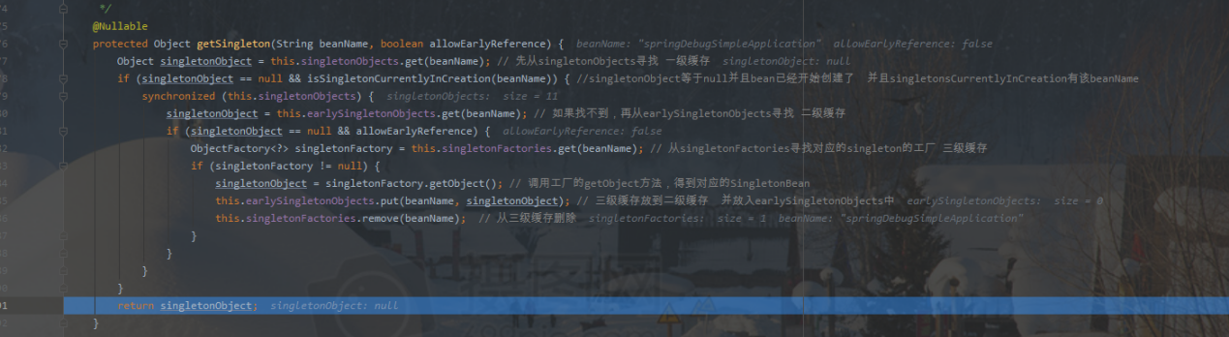

# public Object getSingleton(String beanName, ObjectFactory<?> singletonFactory) {

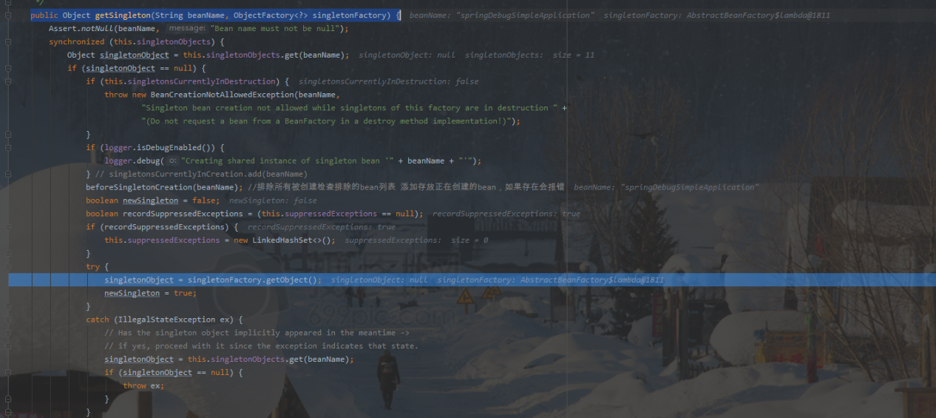

添加到一级缓存singletonObjects

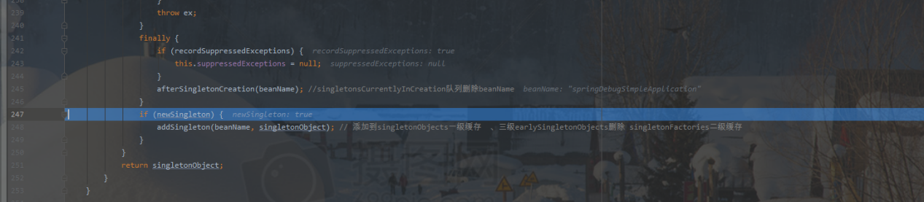

# 没有循环依赖情况下

getSingleton(beanName, true)

BeanWrapper初始化

getSingleton(beanName, false)

使用beanWraper，然后放入一级缓存

# AutowiredAnnotationBeanPostProcessor

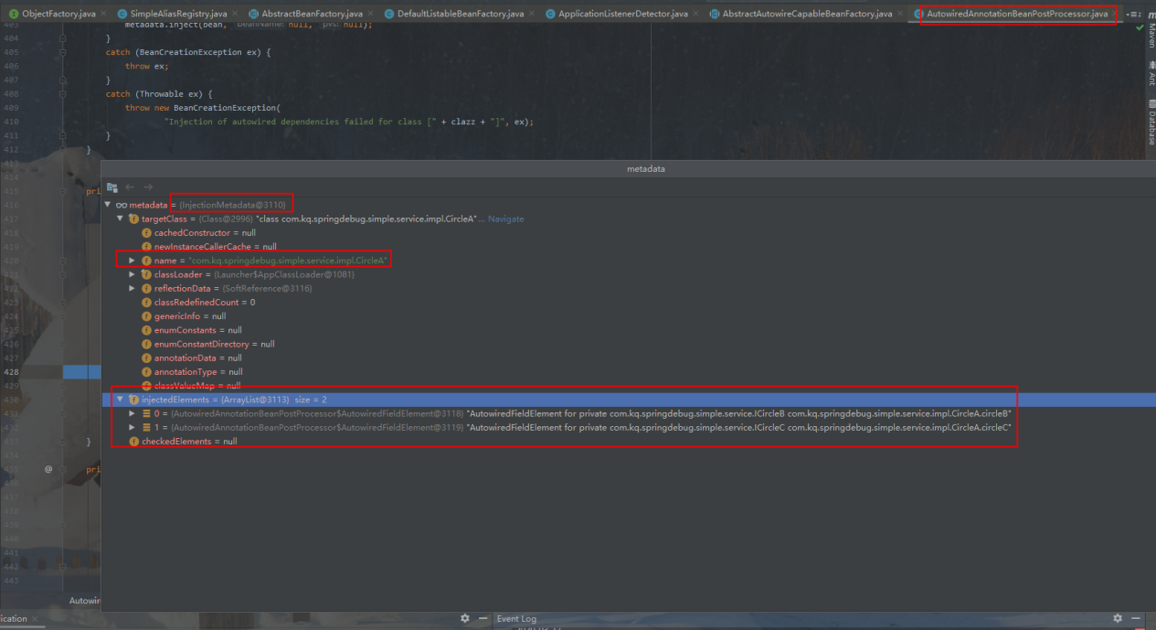

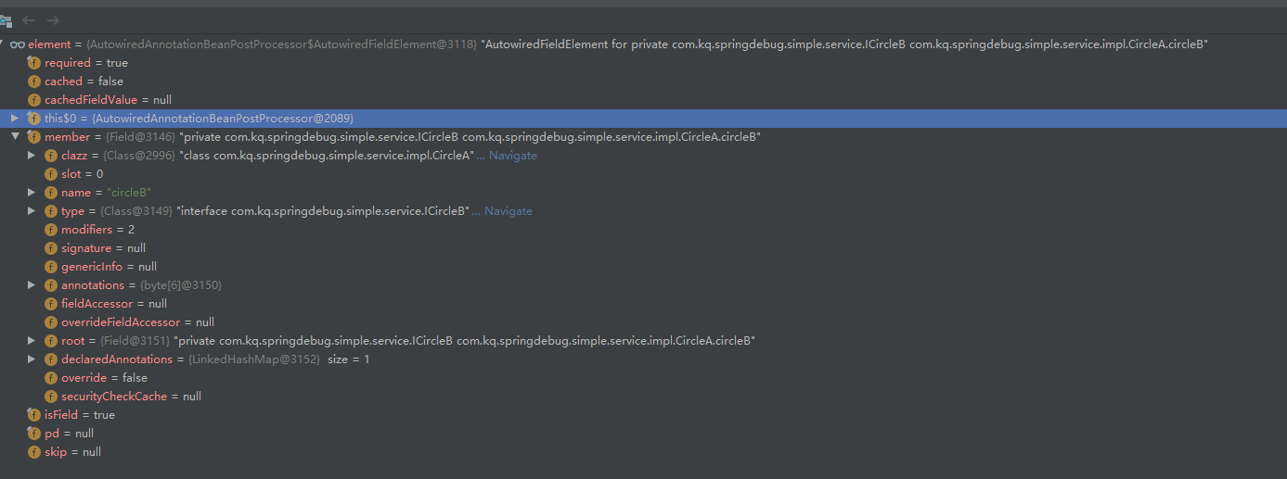

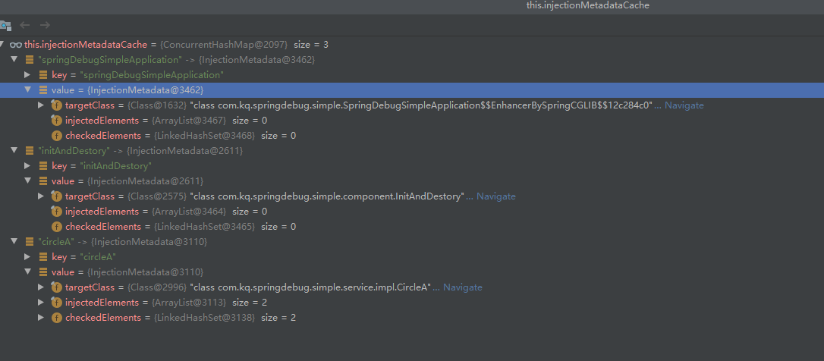

# CommonAnnotationBeanPostProcessor

# DependencyDescriptor(循环依赖重要)

*/** A引用B B引用A 先初始化A 然后A的属性注入B的时候 初始化B 然后B注入A 的时候 调用 这里beanName是A*

public Object resolveCandidate(String beanName, Class<?> requiredType, BeanFactory beanFactory)  
 throws BeansException {  
  
 return beanFactory.getBean(beanName);  
}

@Override  
public Object getBean(String name) throws BeansException {  
 return doGetBean(name, null, null, false);  
}

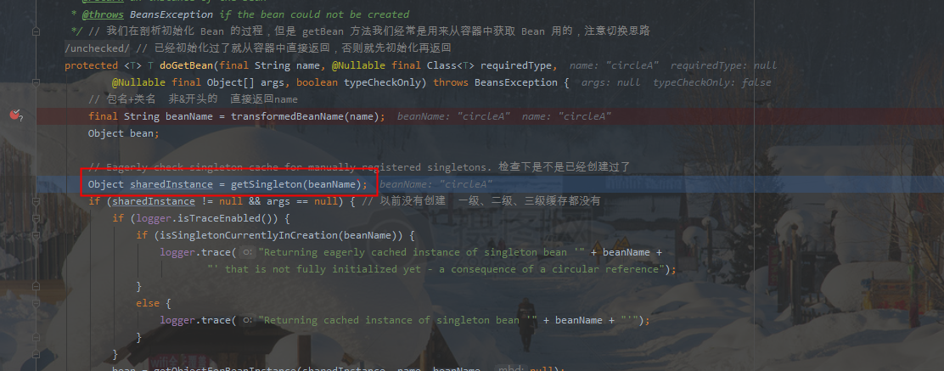

Object sharedInstance = getSingleton(beanName);

public Object getSingleton(String beanName) { // 第一次调用这个 allowEarlyReference=true  
 return getSingleton(beanName, true);  
}

由于A引用B 先初始化A ，A注入B，B初始化,然后B注入A,

这个时候isSingletonCurrentlyInCreation是true

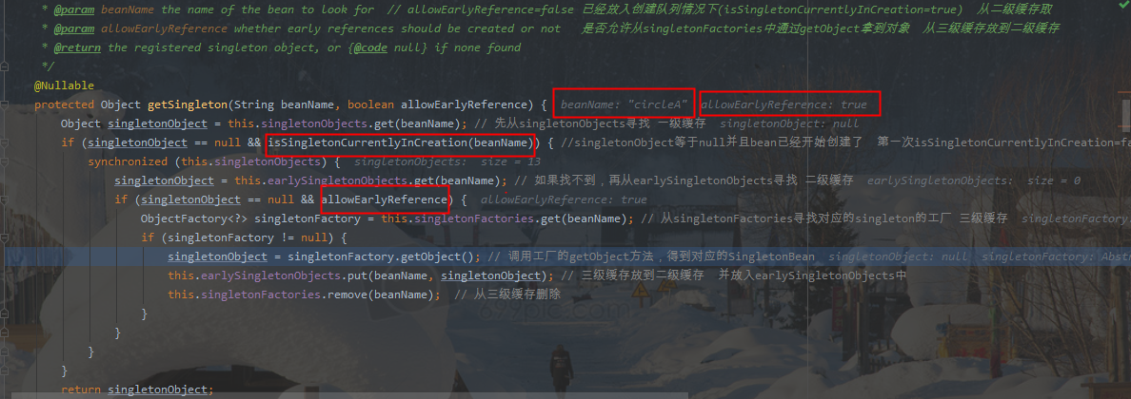

# DefaultSingletonBeanRegistry

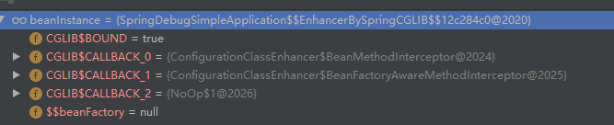

# DefaultListableBeanFactory

# InjectionMetadata

# 重点

org.springframework.beans.factory.support.AbstractBeanFactory.doGetBean

org.springframework.beans.factory.support.AbstractAutowireCapableBeanFactory.createBean

# 加载Bean new

AbstractBeanFactory.doGetBean

## getSingleton

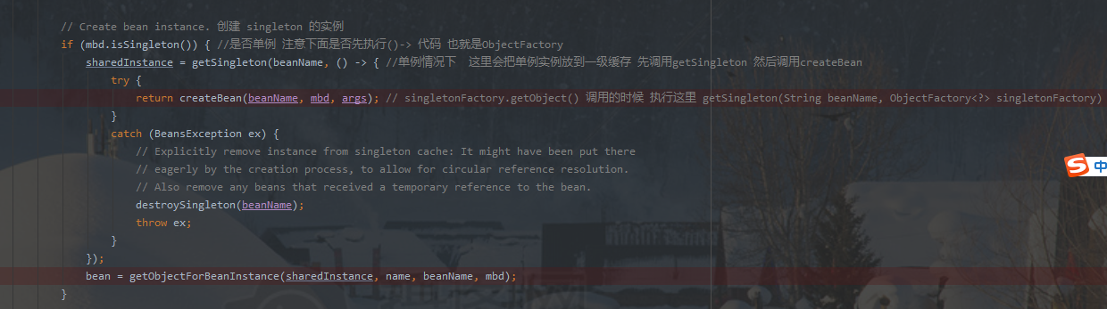

调用getSingleton方法，这里singletonFactory.getObject();会调用上面的createBean方法

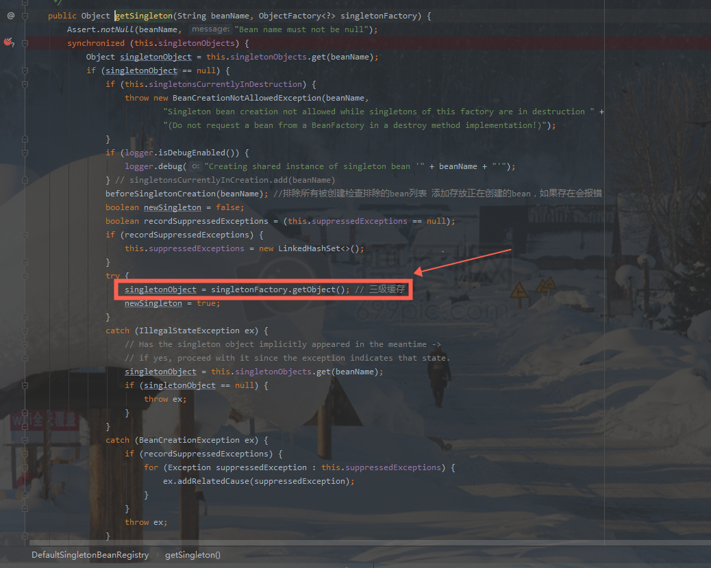

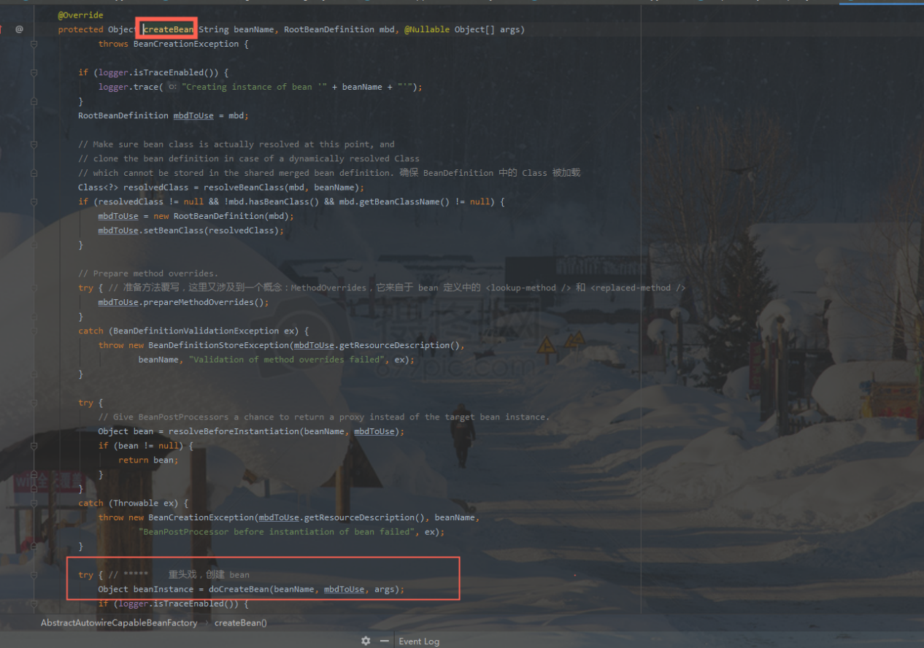

## doCreateBean

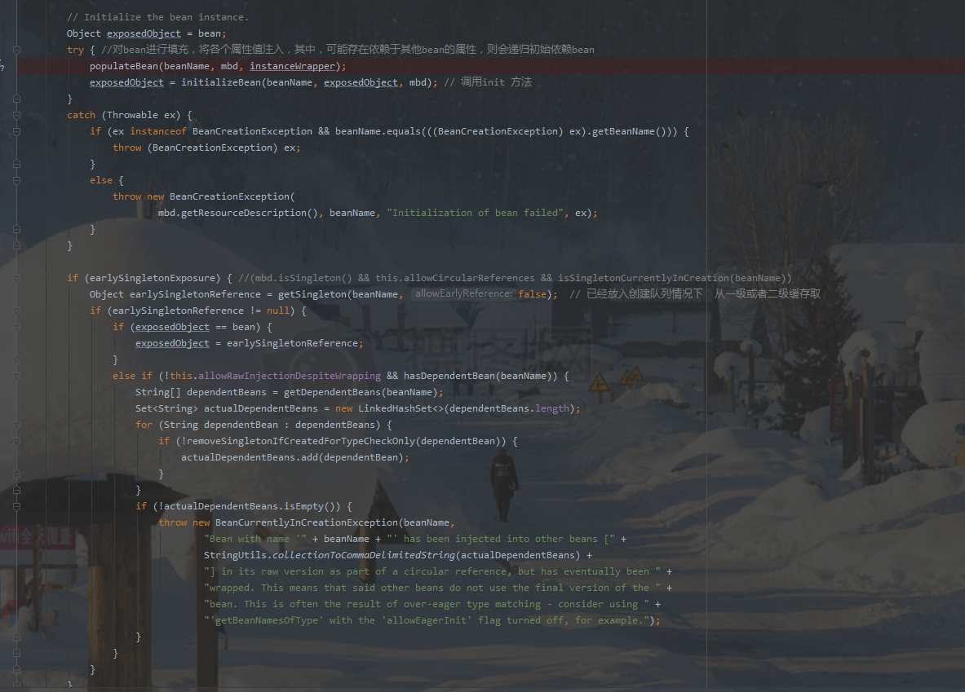

循环依赖的时候，会调用

## getSingleton

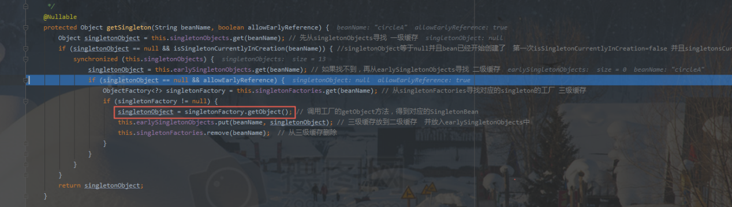

# 文字描述

第一步getBean(), getSingleton(beanName, true),这里返回null

第二步，放入正在创建队列

if (!typeCheckOnly) {

markBeanAsCreated(beanName); //这里才标记 标记已经创建 将当前 beanName 放入一个 alreadyCreated 的 Set 集合中

}

第三步调用

if (mbd.isSingleton()) { //是否单例 注意下面是否先执行()-> 代码 也就是ObjectFactory

sharedInstance = **getSingleton**(beanName, () -> {

// 单例情况下

// 这里会把单例实例放到一级缓存 先调用getSingleton 然后调用createBean

try {

return **createBean**(beanName, mbd, args); // singletonFactory.getObject() 调用的时候 执行这里 getSingleton(String beanName, ObjectFactory<?> singletonFactory)

}

catch (BeansException ex) {

}

});

bean = getObjectForBeanInstance(sharedInstance, name, beanName, mbd);

}

singletonFactory.getObject()调用createBean

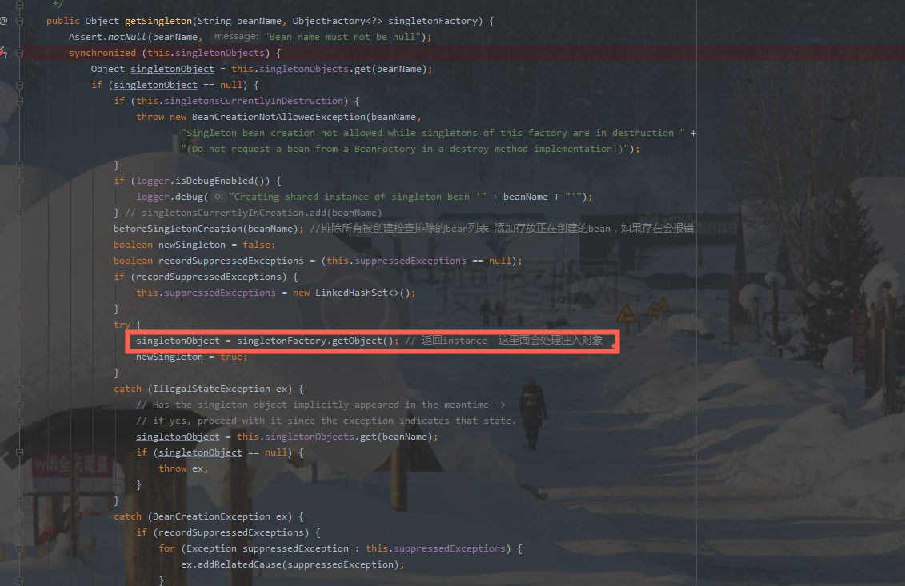

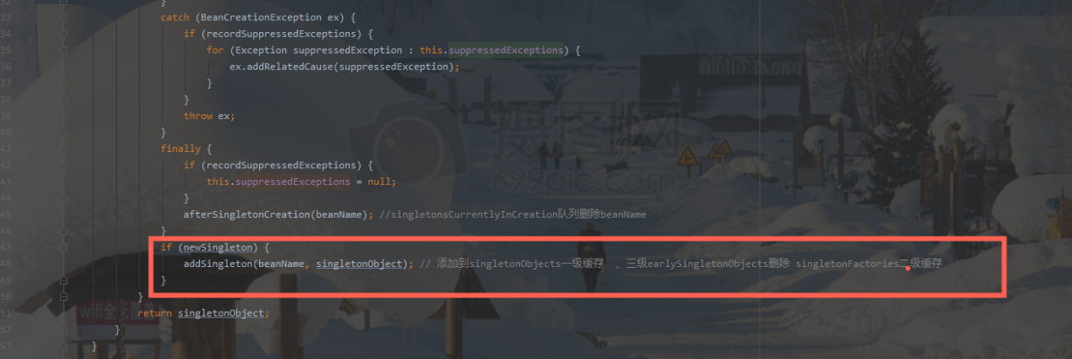

## 三级缓存调用

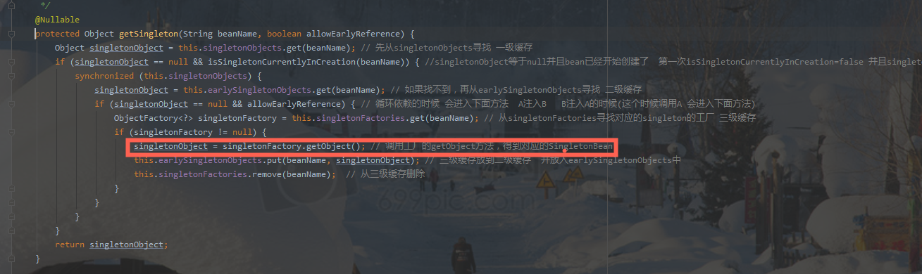

上面调用getObject()，调用下面方法

AbstractAutowireCapableBeanFactory

addSingletonFactory(beanName, () -> getEarlyBeanReference(beanName, mbd, bean));

AbstractAutowireCapableBeanFactory

